【 FORM 1 】 COMPANY NAME ON FASCIA BOARD
Please indicate company name in Chinese and English in the boxes below for the fascia board.

[ 1 ] ENGLISH NAME: PLEASE WRITE IN BLOCK LETTERS

[ 2 ] CHINESE NAME: PLEASE WRITE CLEARLY

If we don’t receive your fascia details before the above deadline, we will arrange the fascia board according to the information supplied by the show organizer.

If you would like to make any change on the fascia board on-site, you have to pay RMB 100.00/set as the extra charge.

If you want to put your logo on the fascia board, please send the printing file(ai or eps format) to us before the deadline.
The production cost is RMB150.00/piece. (The logo must not be larger than 200mm * 200mm.)
□ I would like to put my company logo on the fascia board at RMB 150.00/piece.

EXHIBITOR’S AUTHORIZATION
Contact Person Position
Company Name
Tel. Fax.
Booth No. Email
Date Signature & Company Chop

【 FORM 2 】 ADDITIONAL RENTAL
Items Discription Price(RMB) Quantity Total
A. Furniture Rental
C01C | Black leather chair | 560Wx550Dx820mmH | 130.00
C03C | Office chair | 590Wx610Dx1050-1140mmH | 240.00
C08D | Grey folding chair | 420Wx470Dx810mmH | 45.00
C30B | Meeting chair(white) | 600Wx600Dx780mmH | 350.00
C52 | White leather chair | 400Wx400Dx860mmH | 350.00
C55B | White plastic chair | 490Wx520Wx860mmH | 280.00
C55W | Wood grain chair | 490Wx520Wx860mmH | 280.00
C59B | Meeting chair(white) | 480Wx550Wx800mmH | 280.00
C62C | Meeting chair | 580Wx660Dx880-960mmH | 240.00
C63C | Meeting chair | 580Wx600Dx900mmH | 240.00
C122B | Eames chair | 460Wx420Dx820mmH | 280.00
BS12B | Bar stool(white) | 360Wx400Dx710-930mmH | 180.00
BS12C | Bar stool(balck) | 360Wx400Dx710-930mmH | 180.00
BS29B | Bar stool(white) | 400Wx430Dx900mmH | 280.00
BS29C | Bar stool(balck) | 400Wx430Dx900mmH | 280.00
S11C | Sofa(black) | 600Wx570Dx730mmH | 380.00
S37B | Single sofa(white) | 780Wx710Dx720mmH | 820.00
S37C | Single sofa(black) | 780Wx710Dx720mmH | 820.00
S38B | Double sofa(white) | 1580Wx710Dx720mmH | 1050.00
S38C | Double sofa(black) | 1580Wx710Dx720mmH | 1050.00
S31 | Single sofa | 900Wx750Dx700mmH | 920.00
S32 | Double sofa | 2100Wx750Dx700mmH | 1150.00
CT39B | Coffee table(white) | 550Wx550Dx450mmH | 180.00
CT39C | Coffee table(black) | 550Wx550Dx450mmH | 180.00
CT40B | Coffee table(white) | 1100Wx550Dx450mmH | 230.00
CT40C | Coffee table(black) | 1100Wx550Dx450mmH | 230.00
CT43 | Coffee table | 1000Wx600Dx400mmH | 280.00
RT01E | Round table(white) | 800Φx750mmH | 150.00
RT02E | Round table | 800Φx750mmH | 200.00
RT02F | Round table(black) | 800Φx750mmH | 200.00
BT08B | Bar table(white) | 600Φx1100mmH | 250.00
BT01B | Bar table | 600Φx1100mmH | 250.00
BT03B | Bar table(black) | 600Φx1100mmH | 250.00
MT33 | Square table(white) | 800Wx800Dx750mmH | 130.00
MT35 | Meeting table | 1400Wx700Dx750mmH | 260.00
MT36 | Meeting table | 1400Wx700Dx750mmH | 260.00
AL01B | Information counter | 1000Wx500Dx760mmH | 130.00
AL01C | Information counter | 1000Wx500Dx940mmH | 180.00
AL02B | Lockable cupboard | 1000Wx500Dx760mmH | 160.00
AL02C | Lockable cupboard | 1000Wx500Dx940mmH | 200.00
AL03B | Lockable cupboard | 1000Wx500Dx760mmH | 120.00
AL03C | Display table | 1000Wx500Dx1000mmH | 170.00
AL04 | Low glass showcase | 1000Wx500Dx1000mmH | 320.00
AL05A | High glass showcase | 1000Wx500Dx2000mmH | 550.00
AL05B | High glass showcase | 500Wx500Dx2000mmH | 450.00
AL06 | Information counter | 1530Wx500Dx1000mmH | 350.00
AL07A | Square table | 800Lx800Wx750mmH | 130.00
AL07B | Square table | 750Lx750Wx750mmH | 130.00
AL08C | Cargo rack | 1000Wx500Dx2000mmH | 350.00
AL09 | Flat shelf | 1000Lx300mmW | 80.00
AL10 | Slope shelf | 1000Lx300mmW | 80.00
AL11 | Lockable door | 820Wx1910mmH | 350.00
【 FORM 2 】 ADDITIONAL RENTAL
Items Discription Price(RMB) Quantity Total
A. Furniture Rental
AL12 | Folding door | 820Wx1910mmH | 250.00
CH01 | Catalogue holder | 235Wx55Dx280mmH | 160.00
CH02 | Catalogue holder | 950Wx50Dx280mmH | 190.00
CH03 | Catalogue holder | 250Wx365Dx1500mmH | 280.00
M36 | Bag rack | 600Wx320Dx1250mmH | 200.00
M42 | Wooden easel | 550Wx860Dx1750mmH | 150.00
M72 | Coat hanger | 320Wx320Dx1700mmH | 180.00
AL15 | System coat hanger | 990mmW | 60.00
M01E | Belt barricade | 1000-1200Wx900mmH | 120.00
WB-01 | Waste basket | 280Wx180Dx290mmH | 10.00
EW-01 | Water dispenser (including 1 bottle/day during show) |  | 350.00
EC-01 | Distilled coffee maker |  | 200.00
EC-02 | Capsule coffee machine |  | 2,000.00
EF-01 | Refrigerator 90L |  | 450.00
EF-02 | Refrigerator 140L |  | 650.00
MP-01 | Potted plant |  | 80.00
P01 | Needle punch carpet(per sqm) |  | 25.00
P02 | System wall panel | 990Wx2500mmH | 120.00
B.Audio Visual Equipment
EP-01 | Projector 2500Lumini (include 100 inch projector screen) | 1 day (RMB3000 for deposit) | 2,500.00
EP-01 | Projector 2500Lumini (include 100 inch projector screen) | 3 days (RMB3000 for deposit) | 3,500.00
ET-02 | 42” LCD | 3 days | 2,200.00
ET-02 | 50” LCD | 3 days | 4,000.00
ED-01 | DVD player |  | 400.00
C. Graphic Printing
 | Ink-jet graphic printing | Incl.installation & dismanting | 150.00/sqm
 | Ink-jet printing with forex board | Incl.installation & dismanting | 220.00/sqm

* For more furniture rental, please contact our staff.
* Layout of the booth sketch is preferred.
* Orders without remittance will be canceled.
* All items ordered are on rental basis.Exhibitors will therefore have to pay the compensation for any damages or losses.

EXHIBITOR’S AUTHORIZATION
Contact Person Position
Company Name
Tel Fax
Booth No. Email
Date Signature & Company Chop

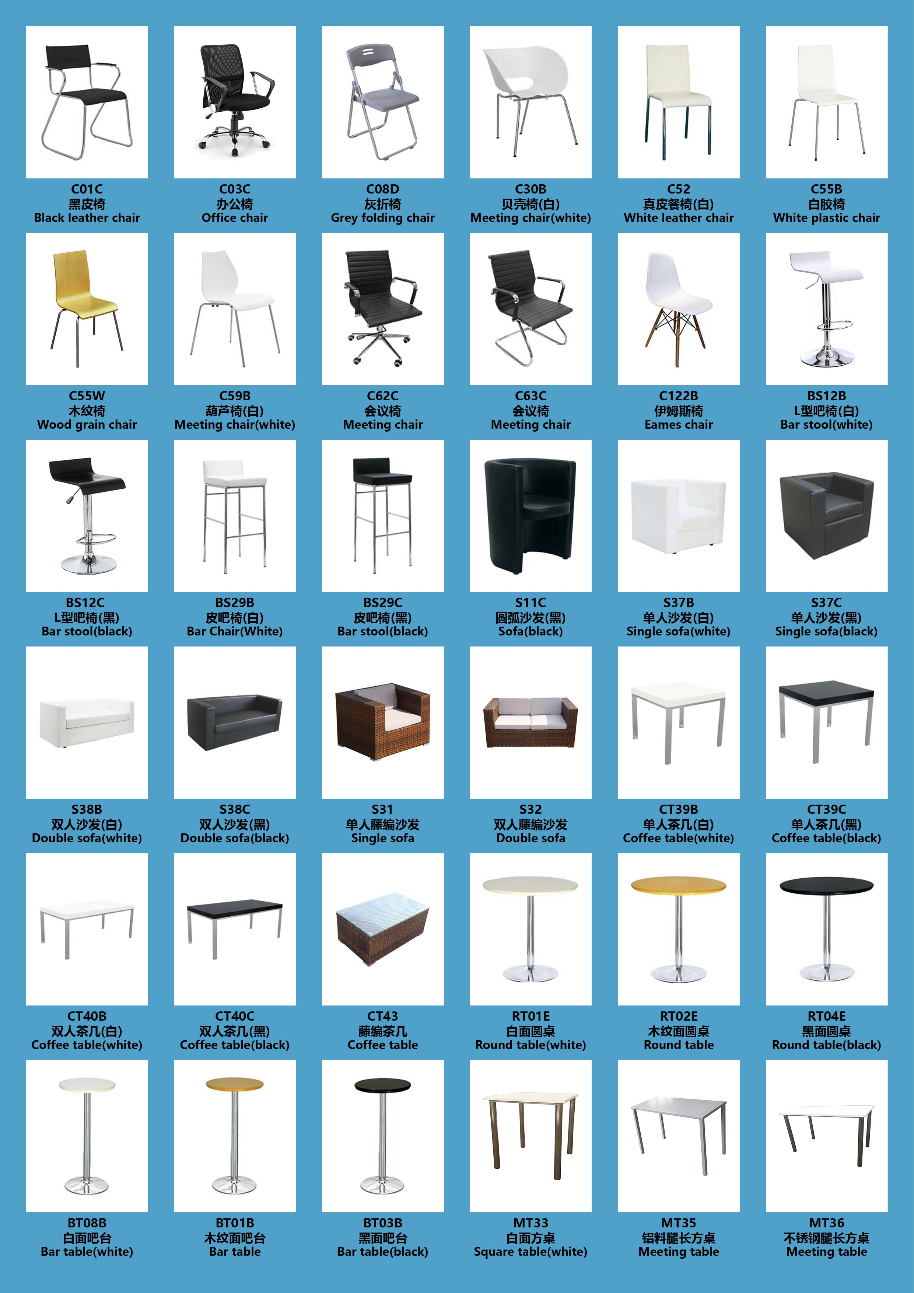
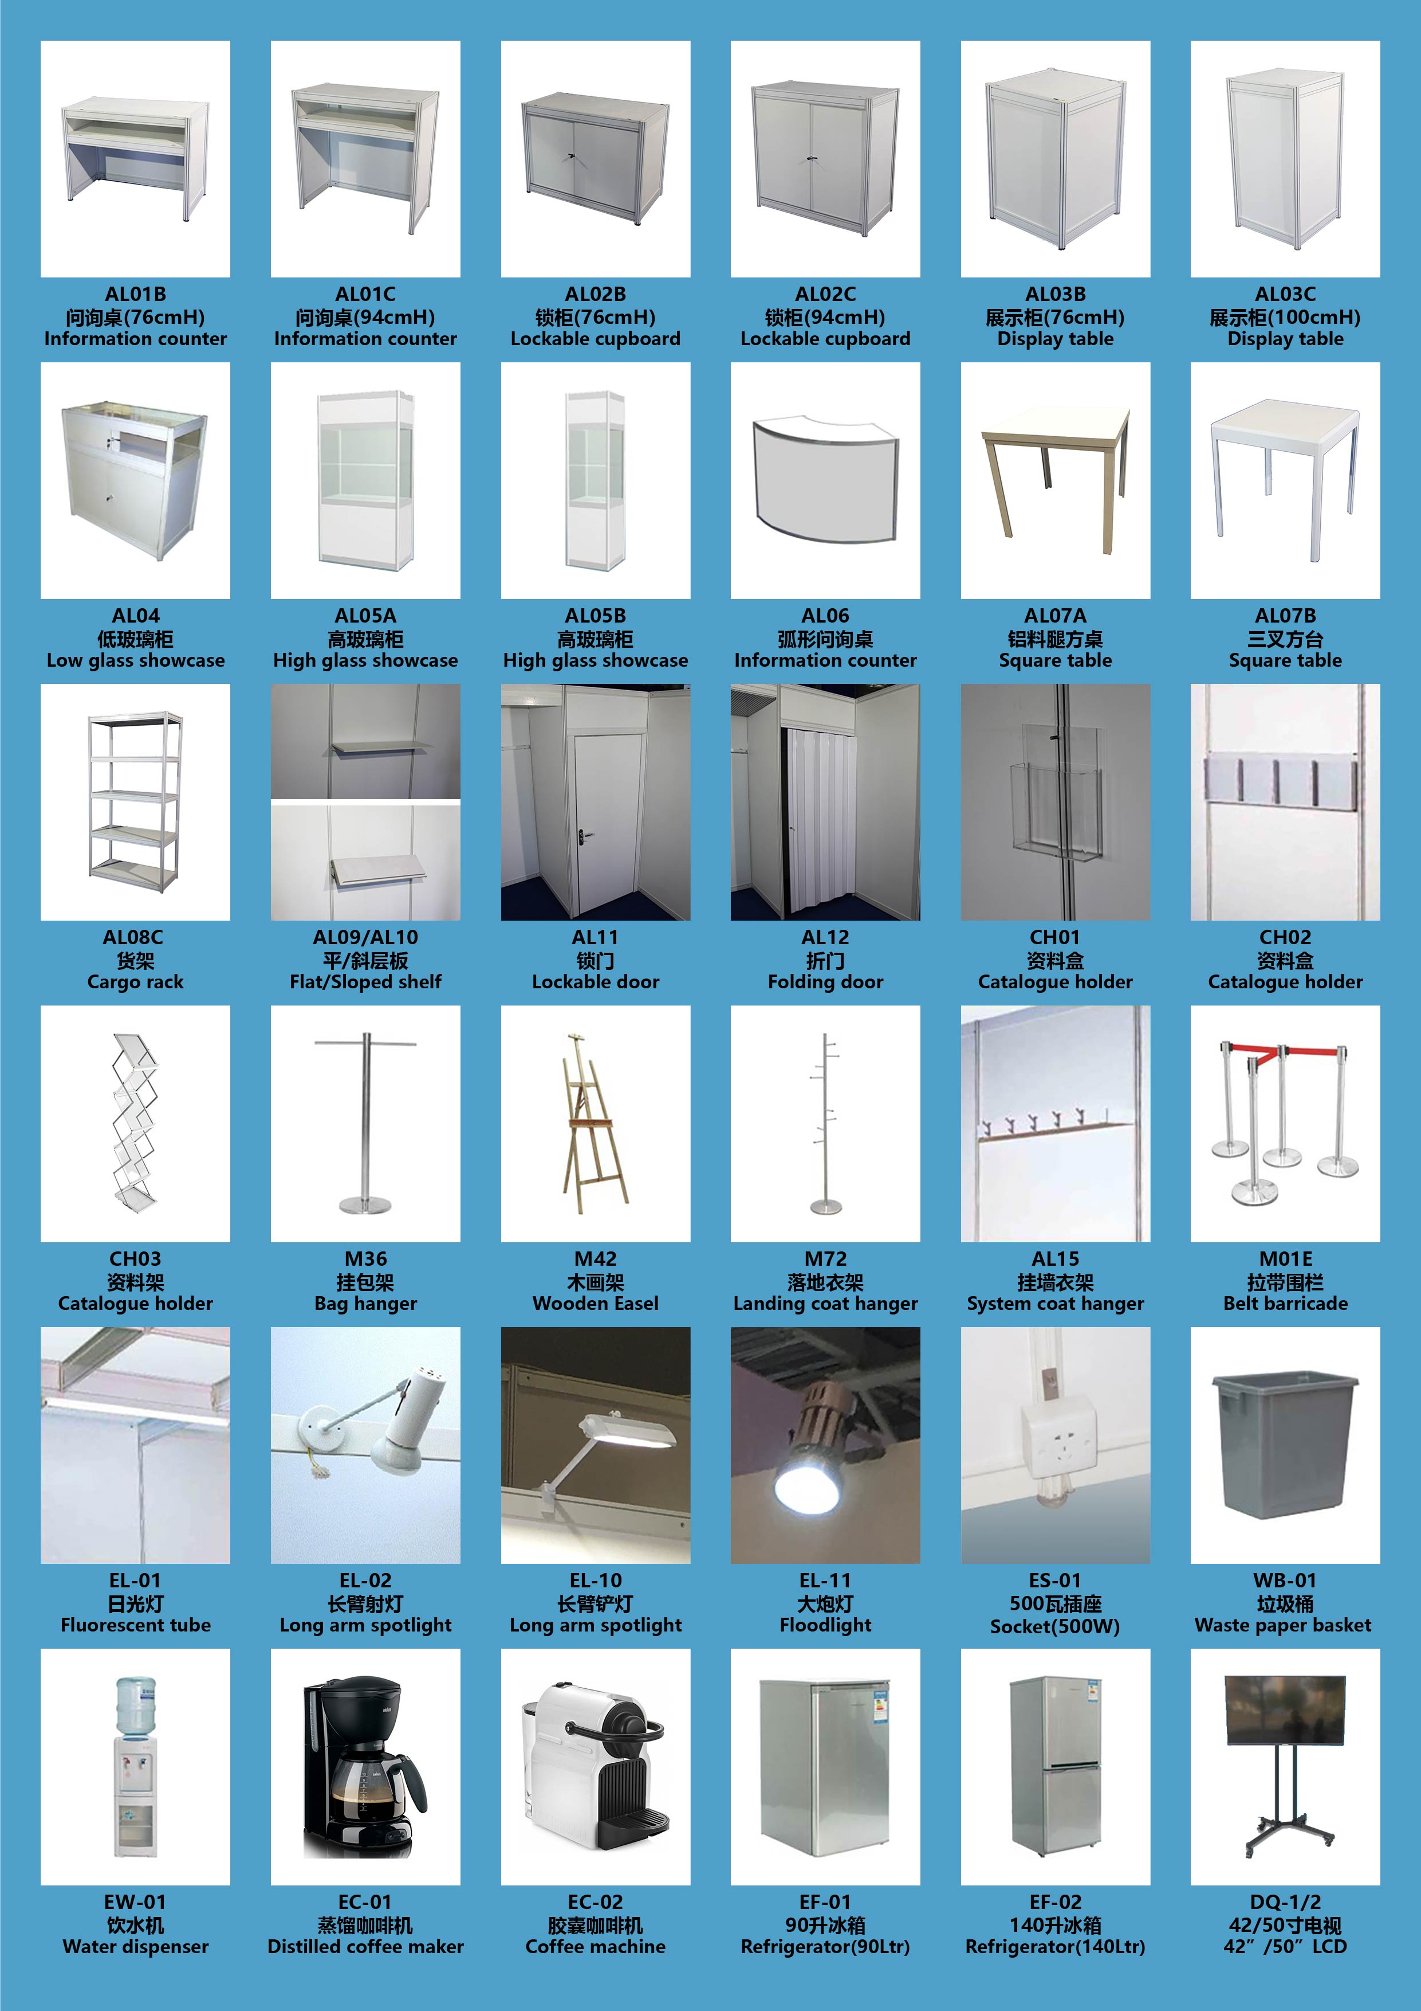
【 FORM 3 】 RENTAL OF ADDITIONAL LIGHTING, ELECTRICITY & OTHERS
Items Discription Price(RMB) Quantity Total
D. Temporary Power Point-For Exhibition period
1 | 16 Amp 220 Volt | 450.00
E. Power Point-For Light Only
1 | 16A/220V Power Point | 1,125.00
2 | 32A/380V Power Point | 3,250.00
3 | 63A/380V Power Poin | 5,850.00
F. Power Point-For Machine Only
1 | 32A / 380V Power Point | 3,150.00
2 | 63A / 380V Power Poin | 5,550.00
3 | 125A / 380V Power Poin | 11,250.00
G. Light & Electrical Connections
1 | 40W fluorescent tube (EL-01) | 120.00
2 | 100W long arm spotlight (EL-10) | 280.00
3 | HQI light(150W) (EL11) | 360.00
4 | 13A / 220V single phase socket ( max. 500 W) | 150.00
5 | Lighting connection, max 100W (with wiring) | 150.00
6 | Lighting connection, max 100W (without wiring) | 120.00
H. Water supply & Drainage
1 | 16 mm pipe & Drainage=50 mm | 2,850.00
2 | 19mm pipe & Drainage=50 mm | 4,350.00
3 | 25mm pipe & Drainage=50 mm | 4,800.00
I. Compressed Air
1 | Compressed air 1/2HP-2HP( ≤0.17 m³/Min) | 2,250.00
2 | Compressed air 3HP-5HP( ≤0.48 m³/Min) | 4,500.00
3 | Compressed air 6HP-7HP( ≤0.71 m³/Min ) | 4,800.00
4 | Compressed air 10HP( ≤0.85 m³/Min ) | 5,250.00
5 | Compressed air 15HP( ≧1.0 m³/Min ) | 6,000.00
J. Telephone Line & Internet Access
1 | WIFI broadband (exclusive)-20M | 2,250.00
2 | Fiber broadband 500 download / 50M upload | 7,500.00
3 | Fiber broadband 1000 download / 100M upload | 9,000.00
K. Rigging point
1 | Rigging point | 3,000.00
2 | Hand hoist -15m chain(max.1000kg) | 450.00
3 | Hand hoist -25m chain(max.1000kg) | 675.00
4 | Electric hoist -15m chain(max.1000kg) | 1,800.00
5 | Electric hoist -25m chain(max.1000kg) | 2,250.00
L. Booth management fee
1 | Booth management fee | 25.00/sqm
M. Construction deposit
1 | ≤54 sqm | 10,000.00
2 | ＞54 sqm | 20,000.00

EXHIBITOR’S AUTHORIZATION
Contact Person Position
Company Name
Tel Fax
Booth No. Email
Date Signature & Company Chop

Remarks & Conditions:
* The above prices exclude electrical consumption fee and all connection to equipment and machines.

* The prices quoted above are subject to the final price list from the hall owner.

* For water supply and air compressor, exhibitors are required to bring along their adaptor for connection to their equipment.

*Exhibitors with very sensitive equipment are advised to bring their own stabilizer to cater for voltage fluctuation.

*Exhibitors have to bring their own special regulating units if they require very specific water temperature or water pressure.

*Any complaint regarding furniture/installation must be lodged the day before the exhibition commences. Otherwise all items are deemed that be received in good order.

*Exhibitors are not permitted to fix their own spotlight or fluorescent light. Special lighting supplies by exhibitors can be handed over to ChanYeer for installation at a nominal price.

*All raw space exhibitors must order one set of main power supply for lighting.
*Main power for lighting/ for machine should be ordered separately.

* Exhibitors are required to mark on the location plan position (Form 7) of their electrical requirements and other equipment. We will install at our discretion if we do not receive any instruction before 30 October,2015. Requests for re-positioning/on-site position will be subject to 50% on the rental price as the relocation charge.

*The deposit for the IDD/DDD should be remitted together with the rental fee. Telephone fee will be charged separately.

*All items ordered are on rental basis. Exhibitors will therefore have to pay the compensation to ChanYeer for any damage or loss.

* Where it is not otherwise stated, the prices are for the duration of the exhibition.

Payment:
Orders without remittance will be canceled, all orders must be accompanied with full payment to the below account either by:
Bank Transferring to our bank account:
Account Name: CHANYEER GROUP(CHINA) CO., LTD.
Account No: 09-123714040005942
Bank Name: AGRICULTURAL BANK OF CHINA
Address: No.599,Xujiahui Road,Shanghai 200023,China
Swift Code: ABOCCNBJ

* Orders without remittance will be canceled.

Later orders:
After deadline (5th Novembe 2024) 30% surcharge will be charged for any late orders.
After deadline (22nd Novembe 2024) 50% surcharge will be charged for any late orders.
50% surcharge for any hall facility’s relocation.
Payment for order cancellation after(20th Novembe 2024) will not be refunded.
50% payment for order cancellation after (13th Novembe 2024) will be refunded.

【 FORM 4 】 SPECIAL DESIGN REQUIREMENTS

If the raw space exhibitors who are interested in appointing ChanYeer as the stand contractor, please fulfill the below basic requirments or email the details to ChanYeer for the further design & quotation.
Company Name:

Booth No.:
Contact Person: |  | Website:
Address:
Tel: | Fax: |  | Email:
Area:

Size:

Open Side:

Basic Requirements:

1.The overall style( luxury, friendly or professional etc)

- Distribution of booth area including meeting, storage and product display area

3.Budget range

4.Photoreferenceof previous or preference booths(email to tony.gu@chanyeer.com).

【 FORM 5 】 FACILITIES LOCATION

All additional items must be marked on the location plan below：

（Scale:1 =1 square meter）

Neigbouring stand
- 100W Spotlight短臂射灯
- 100W Longarm Spotlight长臂射灯
- 40W Fluorescent Tube日光灯
 13A/220V PowerSocket单相插座
A/380V Power Point三相电源
 Air Compressor空气压缩机
Water in/out上下水源
 Telephone电话
Shelf（Flat/Slope）平/斜层板

Neigbouring stand

、

EXHIBITOR’S AUTHORIZATION
Contact Person Position
Company Name
Tel Fax
Booth No. Email
Date Signature & Company Chop

The Important Notice of Raw Space Stand

The provisions of the booth design:
- File: no larger than 5MB.
The file should be named by “Booth number + Exhibitor name + date”
- Please submit the following drawings:
a. Booth perspective drawing ( I front-side & two sides)
b. Floor plan
c. Structural drawing with dimension
d. Detailed booth material list
e. Facilities’ location
C. All drawings submitted to the assigned drawing inspector for review shall be sized in Arabic numbers. DO NOT only specify by grid, in which case, the drawings may be returned without approval. All drawings must be specified in detailed dimensions (M)
D. Only documents with signature & company chop are acceptable. The raw space shall be responsible for any delay that caused.

Notes:
1. All the raw space exhibitors should submit the design drawings to the Tarsus &ChanYeer by themselves or their contractors. Raw space exhibitors without approval will not be permitted to construct their stands.
2. All the raw space exhibitors must submit the final drawings to the below contact before deadline:
Tarsus contact: ChanYeer Contact:
Pere Ramirez Tony Gu
Tarsus Group Plc ChanYeer Group(China) Co.,Ltd.
Tel: +44 (0)20 8846 2706/ 2930 Tel:+86 (0)21 6048 7372
Fax: +44 (0)20 8846 2801 Fax:+86 (0)21 5156 4085
Email: pere.ramirezcaceres@informa.com Email:tony.gu@chanyeer.com

